The Mountain Confederation Caterwauls Summer 2010

Confed Website: http://mountainconfederation.weebly.com/
Current Positions of Service
Senior Servant: Gozen (2006-2011)
Servants: Kahal/Brandan (2009-2011)
Meg the Red (2009-2011)
Sophie (2010-2012)
Beathan (2010-2012)
Ladies Champion: Dougal (2011)
Exchequer: Zara
Slumlord: Izumi
Warlord: Angus

Note from the Webmaster
Hey all. There has been a lot of posting about Pennsic, fighting info, minors, et al going on the list - if you would like to have something added to the website for reference there, please email it to me and just put “Web” in the Subject so I know to post it on there.
Also, still taking pictures, links and whatever else you want up on your website. Check it out! http://mountainconfederation.weebly.com/members.html

Please check your information (SCAdian name spelling, awards, etc.) and that your profile picture is up on the website! Email Sophie (sophie1150@live.com) for any changes and submissions!

..........ps. It is an honor to be nominated, and a conspiracy to be selected as a new servant. you're all a bunch of bastards, but that's why I love you. now stay out of trouble.
Honor Not Honors,
Sophie

Regarding Domesday:

Ellesbeth is revising the Domesday. Please get in touch with her (ellesbeth.donofrey@gmail.com) and check all of your information including your SCAdian name, awards, addresses and emails, etc. She will be sending this for post on the website under the password protected section so that it can only be accessed by members, and we can access and reference it easily at all times.



Recent Notariety
Marcan/Eachvarka won the equestrian tourney at Melee Madness and is the new King’s Equestrian Champion.
Havoc fought very well on Saturday and was one of the last 6 standing in Aethelmearc Crown.

Ladies that Wasn’t Meeting. – May 2010
The 4 orders had nothing to report.
Zara announced we have $1395.81 in the coffers and would put a financial report on the listserv for the gather which she has already posted to the listserv.
Warlord vote was done as a vote of confidence with votes tendered previous the meeting as per the instructions on the listserv as a yes or no. Our new Warlord is Angus. Angus spoke about trying new things, about regional practices, intershires, and had an informal meeting with the fighters after the meeting.
New servants are Sophie and Beathan.
Dougal is our new Ladies’ Champion.
Per Beth, she spoke about the changes regarding minors at Pennsic and new rules that will be imposed. She recommends all parents read the Pennsic book so they know what the rules are. Some that were discussed were no minor can take part of an A&S activity at Pennsic without the attendance of his or her parent. How security will have 2 unrelated adults if any minor needs to be transported. Etc. Any one wanting more details can contact Ellesbeth directly.
Kelly announced we need more sheetwalls as our old ones are still defunct. Zara agreed to put an article on the listserv as to how they are constructed and she has done so. Everyone, especially ones attending Pennsic, please bring a sheetwall panel.
We spoke on burn-out on our Caterwauls editors and suggested that we may want to go back to having 4 editors that rotate.
A discussion was started about what procedure should be if we have individuals who have left the household and would like to return. It was suggested that we have different opinions presented as an article for the Caterwauls for people to mull over and decide. Deirdre volunteered to be a point person; however, if anyone else would like to volunteer to do this, please let her know.
Kelly volunteered to take on Pipers again and reminded everyone about trying out Confed picnic which will replace Confed Pizza before the household meeting.
Deirdre volunteered to organize Margarita Night.
** (Unfortunately, unless something changes financially and quickly, I will be unable to attend Pennsic this year. Therefore, I am looking for someone to carry out organizing the party in my absence. Please contact me if interested. After getting voluteers, the party pretty much runs itself.) **
Respectfully submitted,
Deirdre

Exchecquer's Ladies Event Report:

A HUGE THANK YOU to all who helped with providing food, cleaning up, corralling kids, setting up and taking down tables and chairs, and anything else I may have forgotten. If you helped in any way, please give yourself a big pat on the back.
There were in attendance:
23 men
18 women
5 boys
7 girls
41 adults X $14.00 = $574.00
12 children X $7.00 = $ 84.00
donations = $ 17.93
TOTAL DEPOSIT = $775.93
EXPENDITURES:
$100.00 to replace the $100.00 I took out before Gather for change for Troll
50.00 to ACG for insurance
$600.00 to Bucknell for Site
TOTAL EXPENDITURES = $750.00
PROFIT from GATHER = $ 25.93

Exchecquer's House Report:
I started this job with the money from Katherine or:
$1596.84
Since we've been spending more than we've been making, we now have:
$1132.52
That includes the trailer rental for Pennsic, which I'll be mailing today, but does not include the $200. start-up money for War.
I'm very glad to see that there are more people pre-registered, so perhaps the camp fees will cover the expenses.
PEOPLE: We need to start making money. Someone needs to take on a Ladies Event and start NOW to plan it. I will be more than happy to do background stuff and help anyone who takes on the responsibility. Whoever you might be, you already have a Feast-o-crat (Keldra) and a Troll (me). What is needed right now is an Autocrat and a location (with dates).
In service,
Respectfully Submitted,
Zara the Quiet

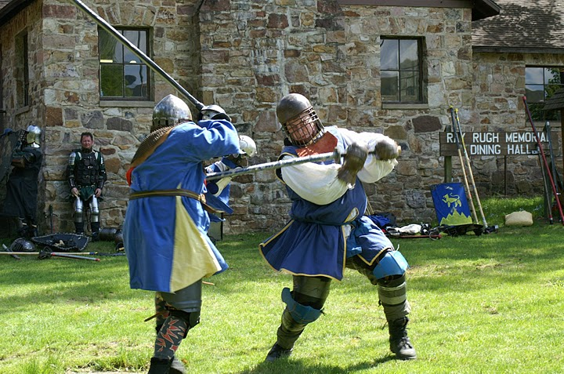

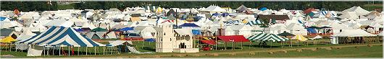

PENNSIC

67 have preregistered for Pennsic

At this time camp fees will be the same as last year with a few changes.
Seed monies for camp will be covered ASAP before monies used for parties. If there is not enough funds to cover some of the expenses then more will need to be collected.
Firewood, water and next year's trailer rental fee are first priority.
For those in charge of other activities, check with the person who is holding camp funds first to see what is available.
CAMP FEES:
--To be collected by Sophie again this year- as much as possible "Landgrab" weekend so that the firewood can be bought the first week.
Pre-registered adult - $10. + $1 (water surcharge) = $11.00
Pre-registered child - (under 16) - $5.00
Non-Pre-Registered adult - 20. + 1 = $21.00
Non-Pre-Registered child - $10.00
The things that get taken out of the camp fees are things like firewood, water, beer for Pipers, prize for Pipers, fliers for Pipers, fruit, etc. for fighters if enough is not donated, same for Margarita Night, next year's trailer rental fee, etc., if there is enough money. Please try to get receipts.
VEHICLES IN CAMP:

I am announcing now that after Wednesday of the first week all vehicles will be required to vacate the camp ASAP with no exceptions.
Autos will be permitted in camp for dropping off your camp, and time to set up then expected to leave at that time.
The only exception permitted will be late night arrivals who can take their cars out of camp the next morning, not afternoon, not evening, but morning.

FIRE EXTINGUISHER:

Would you/your group be able to bring fire extinguishers to comply to the following? (I know that some of you already do so this is just a reminder.)
ALL camps should have the following fire safety equipment:
At least one fire extinguisher rated at 1-A: 10BC for every five, or fraction of five tents that are less than 200 sq. feet, and one extinguisher for every tent over 200 sq. feet. It is recommended to have a 3-A:40-BC extinguisher.
HnH
Izumi
ps. (any and all information is subject to possible changes when on site)

Check out this site http://mountainconfederation.weebly.com/slumlord-guidelines.html for the general rules and guidelines regarding space, camp fees and camping with TMC. Please read as they may have changed from last year.
Both of these links can also be found under the Calendar>Pennsic War 39 (2010) section of the site, along with any other info regarding the event. http://mountainconfederation.weebly.com/pennsic-war-39-2010.html

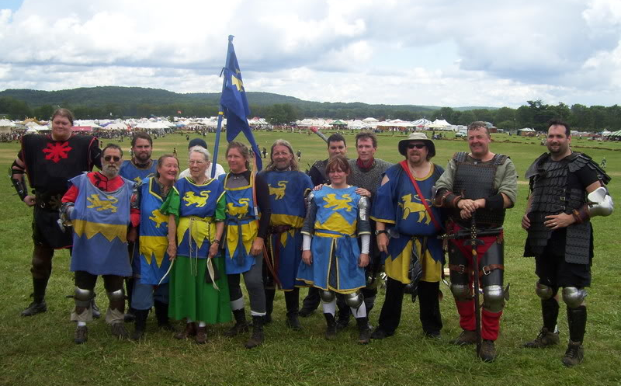

Minors and A&S at Pennsic

There has been an update to the policy regarding minors attending classes in the A&S tents. While they still need to be accompanied, they may now at the parents’ discretion, be accompanied by a designated adult rather than the parent themselves. This is the announcement from Pennsic Cultural Affairs addressing this policy.

"Dear concerned SCAdian, parent, Pennsic teacher, or friend of youth at Pennsic:

First let me suggest that you read carefully my letter on the Pennsic A&S webpage http://www.pennsicwar.org/penn39/cultural.html. It may address some of your concerns. Second, and after you have read the website letter, I would like to clarify some points regarding the new rule:

1. Yes, the rule does indeed go beyond the scope of the Society standard by asking parents to arrange supervision of not just children under 12 but of youth 13-18; however, it applies only to those classes held by Pennsic University in A&S tents.

2. The rule does require adult supervision of youth, by a parent or by a "guardian"--which is defined for our purposes as a responsible adult designated by the the parent to attend the class with the youth. Let me repeat that. We are not requiring a legal court-appointed guardian, simply a responsible adult. (My thanks to the Society MOY and especially to the Pennsic 39 Mayor for allowing us that interpretation of the rule).

3. The teachers of Pennsic classes are not required nor expected to check IDs or ages of anyone attending their classes. We trust that parents will use good judgment in sending their children and youth to appropriate classes; and that the teachers will use good judgment and inform the responsible adult with any youth if material in the class is unsuitable for minors.

4. This rule is in effect for Pennsic 39. The rules for next Pennsic will be set by the Mayor and the staff of Pennsic 40 at that time. This is not Society policy, nor does Cultural Affairs staff wish to debate the justice of the rule. Yes, there were reasons for the rule. No, I am sorry, we will not be disseminating that information for debate in SCA forums.

5. This rule has been in effect since early May, it was not a last minute decision and it was never intended to drive parents or children away from Pennsic. If you find that you cannot adapt to this rule and do decide not to attend Pennsic because of it I am truly saddened, but all I can offer you are my apologies for the inconvenience. If you do decide to return to Pennsic in future years, please take time to read carefully all the rules of Pennsic for that year and follow the announcements for changes (which always happen) as they arise.

Please understand, neither I nor the staff of Pennsic University are against children or youth partaking of all that Pennsic has to offer--my own four children grew up in the SCA, my grandchildren currently attend Pennsic. This rule will affect them as well. I have been a pre-school teacher and a daycare director, I am currently faculty at a state university. So please believe me that I do understand how this may affect your Pennsic, whether you are a parent or a teacher, as I know it will affect mine.

I have and will take time to read all the emails I receive on this matter. I am very impressed by the range of knowledge and experience you all hold as well as the thoughtful responses many of you have taken the time to express. I welcome your input and will pass along your ideas wherever I think they will do the most good. I encourage you, if you would like to make a difference, to offer your services to the fine volunteers running Youth Point and A&S Point. The more sane and sensible folk we have actively participating in volunteer capacities, the fewer rules we are likely to have to make both at Pennsic and in the SCA.

Thank you for your patience and understanding,

Mistress Chai
Deputy Mayor for Cultural Affairs
Pennsic 39"

Please let me know if anyone has any questions. Also please feel free to forward this to your local lists.

~Ellesbeth

New Pennsic University Teen Minor Policy (12-17): (Established 7/12/2010)
Minors are welcome to attend Pennsic University classes. Individual teachers and classes may have restrictions due to topic, materials, request of instructor and such. Unruly or disruptive youth will be asked to leave the class as per Society Seneschal Handbook Policy. Classes specifically geared for minors are handled through Youth Point and will adhere to all relevant policies for youth activities. No classes through the University and Youth Point specifically for minors will be permitted in private camps or merchant booths. Further, any minor who wishes to attend regular University class in a private encampment or in a merchant booth must be escorted by a responsible adult appointed by their parent or legal guardian.
New Pennsic University Service:
The Pennsic University Ambassadors are a group of volunteers organized through A&S Point to aid teachers and students. They will roam through the University areas prepared to help teachers if the “Two Deep Leadership Model” is necessary, aid with basic classroom discipline if required, and assist all members of the populous to find class times and locations as desired. Our Ambassadors are there to help with quick easy questions. For more in depth questions and normal University business, please visit A&S Point in the middle of the University.

~Angus

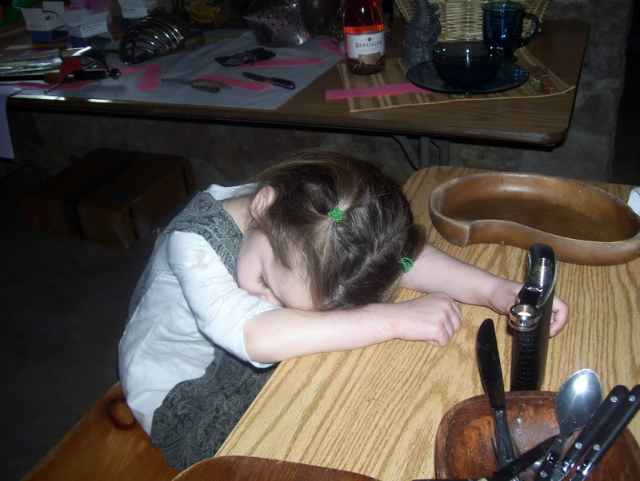

Waterbearer Request
WANTED: FIELD SUPPORT

It appears we will have a reasonably sized camp this year. To me this means many hands to assist with field support.

An inquiry was placed on our list server asking who would be available for field support. We had a small handful of responses. Step up family and let’s take care of our own so everyone can have a great war.

There are a few back to back battles that allow field support to provide a small bite of food to those on a cool down between battles. Hands are needed to prepare these morsels.

We can always use volunteers to assist with water bearing on the field. Anyone willing to sign up for a battle needs to notify Grania or myself. We need at least 4 or more persons per battle. All hands are welcome. If every non-fighter or injured combatant offers time for 1 battle we will have plenty of hands to keep our fighters and archers healthy, safe and having fun. (Which will lead to MANY more “no shit” stories?)

All those who wish to water bare must have appropriate shoes, wear a hat and sunscreen and is willing to take direction. Children under 16 are welcome and needed to water those on the sidelines; they must have parental consent (this means the parents must directly speak to Grania or myself regarding their child’s assistance) and are willing to take direction.

Donation items of Oranges, grapes and other fruits are welcome.

Please review the information on Heat injury and Heat Stroke posted below, for your safety and the safety of our cubs.

And always remember:

***Listen to the Water Bearers of Confed; they are not inflicted with adrenaline/testosterone poisoning, nor are they likely to douse you with ice cold water or a cold spray which could send you into shock. Let us be your field angels…especially if it is suggested you stay out of the fighting for a while. If all goes well you can cus us out back at camp. Then is when I know we have been successful in our job.

HnH
Lady Elidth the Adopted



IMPORTANT INFORMATION: PLEASE READ.
HEAT STROKE WARNING:

Recognizing symptoms of heat injury. There are three stages to heat illness; heat cramps, heat exhaustion, and heat stroke -- listed in order of increasing severity. Often the border between them is blurred into a continuous spectrum. Heat cramps are due to muscle spasms and often occur in the arms, legs, or abdomen. They are thought to be caused by dehydration and loss of salt and other electrolytes. Heat exhaustion is due to more profound loss of water and electrolytes. It is characterized by generalized weakness, headache, dizziness, low blood pressure, elevated pulse, and temperature elevation as high as 104 degrees F (40 degrees C). Both can usually be treated by moving out of the sun, drinking fluids, and eating salty food.

What are the symptoms of dehydration?
The following are the most common symptoms of dehydration, although each individual may experience symptoms differently. Symptoms may include:
- thirst
- less-frequent urination
- dry skin
- fatigue
- light-headedness
- dizziness
- confusion
- dry mouth and mucous membranes
- increased heart rate and breathing
In children, additional symptoms may include:
- dry mouth and tongue
- no tears when crying
- no wet diapers for more than 3 hours
- sunken abdomen, eyes or cheeks
- high fever
- listlessness
- irritability
- skin that does not flatten when pinched and released
(University of Maryland Medical Center)

Some medications interfere with cooling. Certain drugs may cause dehydration or interfere with sweating. Antihistamines and some blood pressure medications decrease sweating. Caffeine and alcohol are diuretics (make you pee a lot) and thus cause your body to lose water. You should avoid their use for several days prior to a battle. (We know that is not going to happen.) For those under a physician's care it is best to check with your doctor about medication -- and about your ability to fight in the heat.

Drink before, during, and after the battle: Hydrate thoroughly the day before the battle. How do you know if you are drinking enough? A good sign of hydration is the output of large volumes of clear, dilute urine.

Hyperhydrate just before the start of the battles. Drinking approximately 400 - 600 ml (13 - 20 ounces) of water or an electrolyte solution can help delay the process of dehydration.
It may seem obvious to drink during the battle, but many people underestimate the magnitude of their fluid loss. It is very difficult to avoid dehydration during a long battle in the heat because the rate of sweat loss usually exceeds the rate of absorption of ingested fluids. The maximum rate of fluid absorption by the gastrointestinal (GI) tract during exercise is approximately 800 ml per hour (27 fluid ounces/hr). The rate of fluid loss through sweating may average as high as 1.5 - 2 liters per hour (50 - 68 fluid ounces per hour). Thus often, despite the best fluid intake, dehydration will occur. Drinking 150 - 250 ml (5 - 8 ounces) every 10 - 15 minutes is probably the best way to attempt to stay hydrated while fighting. For some people, drinking a lot causes discomfort and a feeling of being "bloated". Thus guzzling a liter once per hour will likely cause problems. Also realize that the more dehydrated you get the harder it is for your GI system to absorb what you drink. Dehydration also causes a variety of GI symptoms (nausea, cramping, and diarrhea). You must determine and plan your hydration strategy ahead of time.

Humidity is not your friend. The rate of sweating is higher in humid conditions but the cooling is less. The reason is that because the air is already very saturated with water, sweat can't evaporate. Sweat that beads up and rolls off doesn't function in the cooling process. However, this "futile sweat" does deplete the body of vital water and salt. As dehydration progresses’ cooling becomes more difficult. Performance drops and heat injury becomes a real threat. Deaths have occurred when the air temperature was less than 75 degrees F (24 degrees C) but the relative humidity was above 95%.

Other tips:
You want to enter the battle feeling like you have a full bladder, could pee if had time.
Remove armor; lay flat with feet elevated slightly, cool but not cold towel on head or neck, wrists and ankles.

Sheet walls
Directions for Making Sheetwalls:
Buy 2 yards of 45" or 60" fabric in a medium to dark blue. I should be fairly sturdy fabric - sail cloth, denim, etc.
Turn the 2 cut ends over and then over again to make an extra sturdy hem, so the grommets will hold. The hem should be at least 1 inch wide. 1 1/4 inch is probably better. Sew those hems any way - straight stitch, zigzag, or hand stitch. There should be 1 grommet at each corner.
One side can then be decorated - your arms, a medieval design, a saying, or whatever - or left plain blue. Fabric paint works well.
If you don't understand my directions, ask me. (zaraq@hotmail.com)
In service,
Zara

Ellesbeth found 7oz Cotton Canvas, Royal Blue, 60" Wide. Cost is $3/yd if you order a minimum of 10 yards. Perfect for sheet wall panels. We have donations 11 panels so far. She will pick up the fabric, even hem the panels, as long as people are willing to do the grommets at war. Ideally they should be done first week if possible so we can get the wall up. Contact her if you want to arrange to get some.

Eamonn has a grommet setter. Let him know how many we need and he'll bring enough grommets too. He volunteered to get some grommets for the sheet wall panels as well. So if we need anymore than that, he'll pick them up. Just let him know how many we need. He already has about 16 left from previous years.

This page brought to you by: and the letters P and ennsic!!

Confed Pennsic Picnic Dinner Night

Brothers and Sisters,
Pennsic is almost upon us. Remember in an effort to promote unity and family fun we are replacing Pizza night with Picnic night! So remember to bring picnic items to put on the table to share. Bread, Deli Meat, Chips, Condiments. The Idea is to bring enough to feed your family, put it on the table with all the other "picnic basket contents" and choose from the smorgasbord. Oooh! And don't forget a picnic cloth to sit around the fire with! The whole point is to sit around the fire with friends and family, eat good food and swap no shit stories.
See you all there!
Keldra
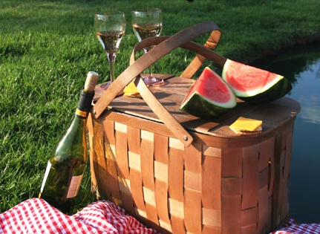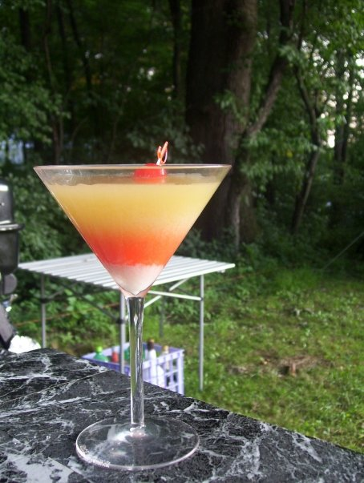
Margarita Night
Drummers are drumming, people laughing in gaudy clothing. The stars and tiki torches are out and the Margaritas and Mojitos are cold.
Can you guess where you are? If you guessed Pennsic, Confed camp on Margarita night you would be correct.

To make any party fab, there are a few things that go into it:
Volunteers and supplies.
I need at least:
3 shifts of bartenders
3 shifts of serving wenches/cabana boys.
Security personnel
ID checkers
Tequila, lots of it.
Rum, lots of it.
Mixers for margaritas & mojitos.

If we rotate people - everyone parties and no one gets stuck with all the work. The last few years have been awesome with the involvement. Last year with such a tiny camp, everyone did a fabulous job pitching in to make it a fun party. The raffle idea that Meg the Red had last year went over well. I think we may do that again, along with gaudiest outfit. The only thing that I would like to add to ramp up the fun a bit more is finding a cheap way to bring entertainment to the party. Anyone has any ideas for PG13 or at worst R rating type of fun, please let me know. (No X rating – sorry) Anyone interested in creating some schtick, let me know what the idea is – I may be able to work with you.
Remember this is OUR party. Let’s make it a great one.
~Deirdre

New Warlord’s Message
Well folks, for better or worse here we are. You all put your faith in me and now I’ll be damned if I know how to live up to it. But I guess I’ll give it my best, and hope I don’t find myself tied to stakes at the bottom of the ravine glazed in honey next to an ant hill… Though I’m sure a few of you hold that vision as your own personal “Happy place.”
I have a few ideas on how I’d like to see things happen as the Warlord in regards to our military aspects within the household. To that effect, I’ve asked a few individuals to act as Deputy Warlords. These individuals will be responsible for certain aspects of things I would like see done, They will also be part of my think tank on how they will be implemented. As of this writing, I have no concrete acceptances. I will be talking to them personally to discuss these positions and by war I hope to have a full cabinet which I can announce to the household.
Now about you. Bet you thought I was simply going to go on about myself and all that How wrong you would be. You see, this is a two way street, I can only do so much, you the fighter of the confederation, you the field support to the confederation. Well you have obligations as well if this is all going to work out. MY JOB is to negotiate for our services, YOUR JOB is to earn that pay by being the best ones out there. For our field support, that’s already well in hand to my opinion. Elididh has done a wonderful job making sure our boo boos are cared for, water in those of us too stupid to realize we’re in need, and afterwards making sure we have something to eat for the long walk home. My understanding is Grania is looking to assist in the management of support as well. I encourage this as it will allow Helen time to do “Helen things” at war finally…
Fighters: Melees will be scheduled to start after Pennsic. I will be looking to set up dates that are not in conflict with local events. For the majority of the household, which means East Kingdom and Aethelmearc . Now before anyone says “What about us” (Most notably you folks out Pittsburgh way) I intend to set these up so everyone has a chance to not travel beyond an hour no more than two unless you want to make the road trip. I also hear some of the guys in Endless Hills would be up for some “Confed vs. the Barony” type melees as well. I suspect these will be in the Hickory Run area as the Barony Boys/gals don’t seem to want to travel much. We will see how that works out.
On an individual basis, PROWESS cannot be mentioned enough. Hit your local practices, check your calendars and hit some of the events in your areas, and fight often. Can’t get out much due to kids? Set up a Pell and work out with it. We might be able to move as a unit, we might look mighty damn fine as a unit, but if we cannot fight like a bunch of stone-cold-ice-water-in-our-veins-killers, we still suck as a unit. Which means we are not earning our pay. IF we can’t earn our pay, they won’t be looking for us to hire.
I actually have more, but if I put it all here, I’ll have nothing for any future articles. So instead of boring you to tears now, I’ll just wait to bore you again come the Fall issue…
Angus

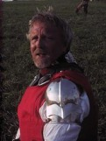

Order of the Cats

HA!!! You thought you only got to hear from me once this issue…Now I gotta do a submission from the Cats as well.
I’m not going to bore you with the Practice Practice Practice mantra. You’ve all heard it, either you’re going to or not. Eventually there may be a “how to” section for the website. That of course will depend upon getting Sophie to put it in there and some of us to submit the how to articles. For now though, any how to subjects are pretty much going to be a result of being at a practice.
I had a few discussions (a lot actually) with those who were not cats. My big question to them was “Were you to be invited into the order, would you prefer induction on the field or around the fire” To this date the overwhelming response was “On the field” and the reason given was damn near identical. It went something along the lines of “We do what we do on the field. This is where we earn it, this is where it should be given”.. Keeping that in mind, I’m asking the rest of you who are not in the order “Is this your preference as well?” Then you need to ask yourself this question. “Am I willing to put in the time and effort to be invited into the order?” If the answer is “Yes” see what I’m not going to bore you with listed above. If the answer is “No,” well then ignore what I won’t bore you with stated above.
Angus

The following link contains the pertinent and required information for anyone doing CA at Pennsic 39:
http://www.pennsicwar.org/penn39/MARTIAL/comarchery.html

The rules for authorizations are posted on the Pennsic War website:
http://www.pennsicwar.org/penn39/martial.html

Malcolm has been informed that Confed will be fighting for Aethelmearc this year. The vote was pretty overwhelming. So people understand what I did to keep score, anyone who said "East or Aethelmearc is fine with me" I put a check mark beside East and Aethelmearc giving full weight to both. I did this with all the contenders which resulted in combinations of Union and East or Union and Aethelmearc, etc.

As I was leaving last night His Majesty advised me to "Have a name ready for him" for the Allied Champions Battle as well as "Make sure you have two more in the wings and ready." This leads me to believe we are looking at a potential three slots for this battle.

According to the Schedule, this will be held at 10am on Wednesday of war week. I have a good idea who I would like to take the first slot, and possibly the second. The third is up for contention to decide that, a grinder will be held on MONDAY so that word can be given to his Majesty well in advance and avoid any confusion.

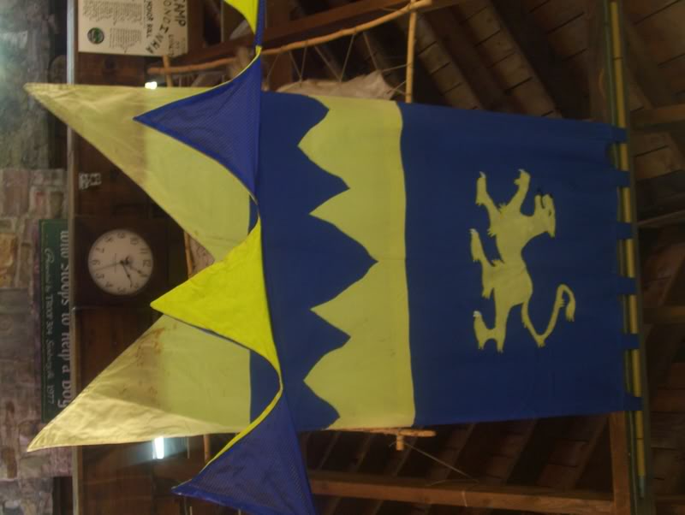

MINORS
(The following does not apply to Youth Combat systems)
If you will be age 16 – 17 this year at Pennsic you may want to sit down to read this.
Any combatant authorized in adult heavy weapons and/or adult rapier combat will be allowed to participate with adults at Pennsic War 2010 regardless of their age. This will be mentioned in the June AEstel and more fully detailed in the July AEstel.

Authorizations of Minors must be performed by your Earl Marshal for Heavy Weapons and by the Kingdom Marshal of Fence for Rapier. Few events are left to get this done so please contact me ASAP to make arrangements if you are a minor who wishes to authorize prior to Pennsic.
In addition to what is required of adults to pass inspection at Pennsic minors must mark their Helm/Fencing Mask with four 2" x 2" Yellow Diamonds (Duct Tape is acceptable for marking) one on each side of helm/mask.

Minor's inspection sticker will be marked with the word "MINOR". No one can inspect minors in camp. They must be inspected at marshal point by the senior marshal at the point.

As a reminder to everyone, and especially to new people attending Pennsic:

Read ALL the rules and regulations that pertain to this specific event. They can be found on the Pennsic web site: http://www.pennsicwar.org/penn39/GENERAL/siterules.html. There are things that if violated not only effect the individual but also the entire group that they are camping with. The Coopers can have anyone removed for the site for any reason that they choose. There are also mundane legal issues related to the rules. With much of the current events and concerns in the mundane world, some of the more sensitive issues this year deal with possession of explosives, firearms, or illegal drugs and child abuse situations. With explosives and firearms it does not matter if you can legally be in possession of such in PA. The same with known illegal drugs for PA (we are not in California). And I think that everyone knows what the Household position is on child abuse in addition to Pennsic/Coopers rules.

Remember this is to be a "fun" time for everyone.

~Angus

Good To Note:
As Dierdre pointed out being the Editor of the Caterwauls is not an easy task. Though I would correct the assumption that I was not burned out from doing it, merely with my schoolwork I had no time to do. I, being the sick lil Pup I am, actually enjoyed it. Then again, as my brothers and sisters who are also of the Shire can attest to, I had a standing policy of if you don’t submit something I will make something up, and usually did.
Meg the Red, and MSG to an extent, have actually put great Caterwauls on the site. Meg badgers everyone for months about submissions, starting pretty much right as soon as one issue goes up , she calls for submissions for the Next. This is where the burn out comes in. Several people are very good about submitting stuff, Havoc and Angus regularly throw in stuff for the Cats, Gozen does for the Centaurs and Zara for Financial Reports, even Deb submits things semi regularly. But then there are the times that any editor would need to practically beg for a recipe or something just to throw in. Without going into a psychological evaluation of why this is, I would think this reflects poorly on the attitude of the House as whole. When I first joined, the Caterwauls was filled with stuffand was enjoyable to read, now it is a pale reflection of itself even though it has the capability with being online to be so much more.
I know usually when a message like this goes out there is a flood of “Use this” , and “you can post That ” type suggestions. Personally I don’t think the editor should have to do your work for you other than fixing your spelling and run-ons …maybe. I was always one to let people dangle the participles proudly. If you think the editor might be able to use something send it to them yourself.
This is Our House, Our Family , our Caterwauls. We should be willing to share shit like recipes and armor Patterns and achievements freely.
DOG

Future Area Events:

July 16-18: East Kingdom Southern Region War Camp, Eisental, Lehighton, PA
July 31-Aug 15: Pennsic War 39, Slippery Rock, PA
Aug 28: Post-Pennsic Picnic, Debatable Lands, Slippery Rock, PA
Sept 3-6: Swamp Thynge XX – Caer Adamant, Middletown, DE
Sept 10-12: Green Lane Scottish/Irish Festival, Hartshorndale, Green Lane, PA
Sept 10-12: Children’s Crusade II, Steltonwald, Hookstown, PA
Sept 18: Fall Coronation, Hunter’s Home, Grove City, PA
Sept 25: Pirates Adventure: Courtlandtslot, Preble, NY
Oct 1-3: Archers to the Wald, Steltonwald, New Brighton, PA
Oct 9: Queen’s Rapier Championship, Stormsport, Erie, PA
Oct 9: Panathenaea Festival and Games, Montvale, Shippensburg, PA
Oct 15-17: Meg the Red in the Komen 3-Day Walk, Closing Ceremony (come watch! Philadelphia, PA

Post-Pennsic/Fall Caterwauls
The Post-Pennsic/Fall Caterwauls will be published mid-September.

Please send submissions to Megan by email by Monday, August 30th:

Include:
Pennsic News, Outstanding Happenings, No Sh*t Stories, Classes taken/learned,
Battle Stats, Margarita Party, Confed Family Picnic, Camp Stats (number of
people, note-for-next-time)
Fall Events
An article explaining Caterwauls Editor rotation
Etcetera

Also, I’d love to see ONE “Perfect Pennsic Pic” from everyone who went to Pennsic, to share with those of us who couldn’t make it! Please email me One (or 2 if they’re really, really classic) picture from Pennsic with a short caption and I’ll make a little photo gallery in the next Caterwauls.

(this thing just gets longer and longer as I play editor!...)

